**DEPARTMENT OF LAW**

**DR. AMBEDKAR COLLEGE, DEEKSHABHOOMI, NAGPUR**

**REPORT ON INDUCTION 2023-2024**

**(5 DAYS INDUCTION PROGRAMM)**

**ABOUT INDUCTION PROGRAMME**

|  |  |
| --- | --- |
| **NAME OF THE PROGRAMME:** | **Induction Program for Newly admitted students of LLB I SEM ( 5 & 3 Years course)** |
| **DATE AND DAY:** | **4th October, 2023** |
| **TIME:** | **11:30AM- 3.00 PM** |
| **GOOGLE MEET LINK** |  |
| **PROGRAMME CO-ORDINATOR:** | **Prof. Dr. H.V. Menon, Head of Dept, Law and Dr. Varsha Desphande Coordinator Induction Programm.** |

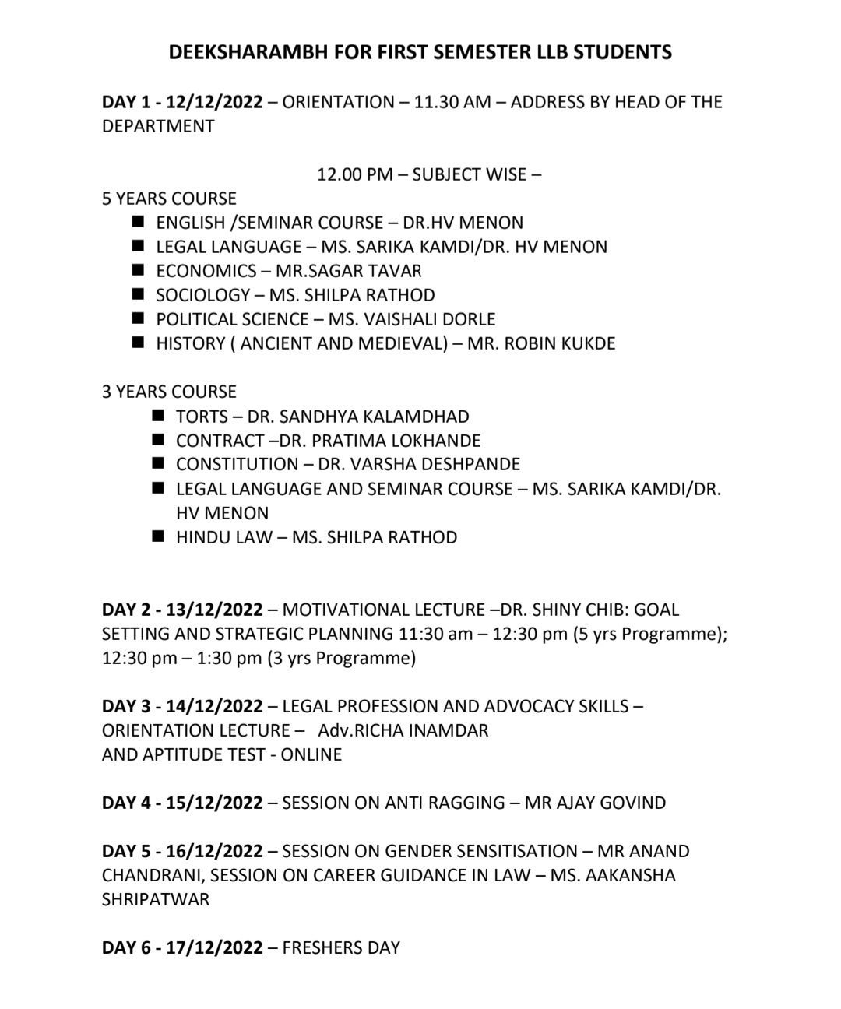

Induction Program was conducted by Dr. Ambedkar College, Department of Law, Deekshabhoomi, Nagpur for the newly admitted students of LLB I Semester (5 years course and 3 years course) from 4th to 9th October, 2023. In all ----­­­­­­­ students (__ students from 5 years course and ___ students from 3 years course) attended the program. The program was conducted under the guidance of Prof. Dr. H.V.Menon, Head of the Department of Law, , Dr. Varsha Deshpande Incharge Induction committee, by different Faculty Members Dr. Sandhya Kalamdhad, Dr. Pratima Lokhande, Mrs. Vaishali A. Sukhdeve, Ms. Shilpa Rathod, Ms. Sarika Kamdi, and was attended by all Visiting Faculties teaching in LLB I Semester.

Five day Induction program (4th to 9th October) was set with an objective to provide a platform for the transition of the students from different background to professional course of law. It was brought in with a view to uplift the level of the students and to promote all round development of the students. To help them adjust to the new environment and inculcate in them the ethos of the Institution.

The Induction program was brought in with a view to educate and to acclimatize new entrants with the new surroundings of the college and to build strong relationships with faculty and peers. To nurture a deeper understanding of the subjects and develop bond amongst all setting goodlearning experiences and also to draw the attention towards exploring their academic interests and activities.

**DAY 1 (4/11/2023)**

**INAUGURAL FUNCTION**

**ORIEENTATION BY**

**H.O.D Dr. H.V.MENON**

To mark the beginning of the academic year and induction program Dr.H. V.Menon head of the department inaugurated the program. To achieve the above set objectives, Head of department of Law, Prof. Dr. H.V. Menon, gave an insight into the overall operating system of the institution as well as department of law. By introducing all the regular and visiting faculties to the Students and also informed about the subjects teachers in the LLB I Semes. Prof. Dr. H.V.Menon, instructed about the rules, regulations and responsibilities of students at the time of attending the Online as well offline classes and maintaining proper decorum by Students with respect to wearing of Uniform, Identity card and use of mobile phones in college.

She addressed the student by telling them how Life on campus is colorful. There are many activities they can be part of in the college. And she wished that each one of them will participate in them. She said that the college is not just to gather information but they must learn [character, discipline, compassion,](https://www.bpps.in/2020/03/15/coach-gives-inspirational-confrontational-pep-talk-to-his-team-on-the-importance-of-time-and-discipline/)and above all understand [the meaning of life and the profession that aspired them join this profession.](https://www.bpps.in/2016/01/04/2-minute-speech-on-the-meaning-of-life/)

She emphasized the importance of transcending the knowledge of law into application for the betterment of society having given the warm welcome to the student she appealed the student to utilise maximum resources at most their capacity for their own academic enhancement.

She also emphasized on Co-Curricular based learning clubs that students can join as per their interest. The Constitutional law Policy and Public Debates Club headed by Dr.Varsha Deshpande.The Criminal Law Club Headed by Dr.Sandhya Kalmdhad and the Legal Aid Clinic headed by Dr.Pratima Lokhande

**DAY 1 (4/10/2023)**

**SUBJECT WISE ORIENTATION**

**11A.M-4P.M (3 & 5 year course)**

**Dr. H.V.Menon-Seminar Course**

Dr. H.V.Menon focused the importance of language in studies particularly in law and how it is important to understand law. She explained how one can developed good oration skills with the help of good vocabulary and command over the language. She emphasized on attendance, rules and discipline, importance of regularity, uniform and other important things relating to study, course and punctuality and gave best wishes to the students.

**Dr. Pratima Lokhande –Contract Law**

She began with telling the students the importance of the theoretical understanding of contract law and its practical orientation needs relevance and challenges. The second session was taken by Dr. Pratima Lokhande and she discussed about Contract Law. She gave a brief introduction on the subject and importance of this subject and the books that we can refer for the same.

She told the student that this particular subject will provide them with an overview of various types of contracts and the building blocks of contract including of a acceptance and consideration students learn about defects and contractual relationship such as misrepresentation, mistake, frustration in legal terms. Further, more students are introduced to the remedies available in case of breach of contract. Various classroom activities will be carried out to encourage the students to apply then knowledge to decision base scenarios and case studies.

**Mrs. Khushi Bajaj-Hindu Law**

Mrs. Khushi Bajaj took the 3rd Session and introduced herself. She took the session on family law and legal language. She discussed about Hindu Personal Laws and Legal Language. Further, she discussed about sources of law and about the various statutes that the students will be studying during the course.

**DAY 2 (5/10/2023)**

***SUBJECT WISE ORIENTATION***

**(3 & 5 years course)**

**Dr. Pratima Lokhande –Contract Law**

Dr. Pratima took the first session of the day and introduced ‘Contract Law’ to the students. She interacted with few students and asked about their basic understanding of Contract Law. After few inputs from the students, she discussed about basics of Contract Law and started with brief Introduction to Contract and Indian Contract Act. She started the discussion with Agreement and Contract and the difference between the two. She further discussed about the definition of Contract and essentials of Contract.

She told the student that this particular subject will provide them with an overview of various types of contracts and the building blocks of contract including of a acceptance and consideration students learn about defects and contractual relationship such as misrepresentation, mistake, frustration in legal terms. Further, more students are introduced to the remedies available in case of breach of contract. Various classroom activities will be carried out to encourage the students to apply then knowledge to decision base scenarios and case studies.

**Mrs. Khushi Bajaj-Communication Skills for Lawyer**

Mrs. Khushi Bajaj took the second session of the day and spoke on the importance of Communication skills for Lawyer. She explained the importance of communication skills for a lawyer and it is an extremely important aspect to have a good command on communication skills. During the session, she emphasized that you need to have good public skills and communication is an important key for the Lawyers. She discussed that having good orator skills will give you immense confidence in the field and you will have good opportunities coming your way in the future.

**Mrs. Khushi Bajaj- Hindu Law**

Mrs. Khushi Bajaj took the third session and delivered lecture on Hindu Law and spoke on the nuances of Hindu Law and the Acts that we will be studying during the course. She discussed about the importance of studying personal laws and how personal laws are important in our day to day life. She entailed that with increase in divorce cases and child custody studying personal laws have become extremely important and how the courts are also evolving and the change in thought process of the Judges with changing times in personal laws. She discussed that judges have become extremely avid in Divorce cases and thing are slowly become progressive.

**DAY 3 -6/10/2023**

***SUBJECT WISE ORIENTATION***

**(3 & 5 years course)**

**Dr. Sandhya Kalamdhad-Tort Law**

Dr Sandhya Kalamdhad told students that tort is a challenging field of law because it deals with everyday human experience and tragedy.Tort law is all about contemporary society -the accidents we experience, the personal and family relationship we create, the technology we use and societal mores we continue to evolve and reformulated.

Tort is not only relevant to injured victims and their lawyer but is also vitally important to the society as a whole the business and the corporate community, the Health Care industry and the profession also of all types. Tort law most definitely is not a stodgy, old compartment of common law; it is a vital component of living common law.

**Dr. H.V. Menon- Legal Writings**

Dr. Menon gave introduction on legal writings and its importance. She specified that being a lawyer we should be updated to the current legal affairs and that we should be updated with the landmark cases and the ongoing recent judgments. Accordingly, she gave an assignment to the students to write on two topics

1) Current Legal Related News

2) Report of Five days of classroom

She asked the students to write on these two topics so, that we are able to adjudge our writing and how well we can write. As lawyers, Research and drafting is an integral part of our profession. In future, Research Papers will become a mandate. So, students should be well-versed and with time keep on working and improving on Legal writing so as to excel in this field.

**Dr. Pratima Lokhande- Contract Law**

Dr. Lokhande took Contract Law class and discussed about vitalities of contract. She discussed the definition section of Contract Law and discussed about agreement, acceptance (verbal and written), consideration and other essentials that are required for a valid contract. She explained the class with plethora of examples and live examples. Further, she discussed why these elements are important and its relevance in Contract Law. Over the period of time, Contract Law has become extremely important as things are becoming more commercialized and with evolution of entrepreneurship Contract Law has become an extremely important thing to discuss.

**Mrs. Khushi Bajaj- Hindu Law**

Mrs. Khushi took the session on Hindu Law and started discussing about the various sources of Hindu Law like Ancient and Modern. She explained the meaning of Precedents, Legislation, Justice. Equity and good conscience. She further explained that Personal Laws are an formulated through these sources and this the basis of Personal Laws through which these Laws have been imbibed and the some rituals and customs are a part of personal laws which might vary from community to community.

**Mrs. Khushi Bajaj-Legal Language**

Mrs. Khushi discussed about legal maxims and discussed various maxims. Some of the common maxims that as Lawyers we need to learn and use are:-

a) Actus Dei Nemini Facit Ijurial

b) Actus Not Facit Reum Mens Sit Rea and two structures Actus Reus and Mens Rea

She further discussed the meaning of Actus Reus and Mens Rea and these two components are very essential in Criminal Law.

**DAY 4-07/10/2023**

**Adv. Sumedh Kadam- Law, Life & Beyond**

**1st Period- 11.30 A.M.**

Teachers and Students welcomed Adv. Sumedh Kadam. He is practicing in Nagpur High Court and has an extremely renowned name in the Court. He started by saying that he was once a student of the department. He further discussed about the function of laws. He further enunciated on being an Advocate and Judge and how their functioning differs in terms of work. Further, he entailed that you should try and understand your goal whether it’s Advocacy or Judiciary and work with full zeal and zealous. He tried to clear all the doubts raised by the students and tried to respond to all the queries within a stipulated time.

**Dr. Sandhya Kalamdhad- Law of Tort**

**2nd Period- 1:15 P.M.**

Dr. Sandhya spoke about Tort Law and explained definitions of Tort given by various jurists. She emphasized and focused on the definitions of Tort given by Salmond and Winfield and why definitions of these two jurists are important and the difference between the definitions.

**Mrs. Khushi Bajaj- Hindu Law**

**3rd Period- 2P.M.**

Mrs. Khushi Bajaj took Hindu Law and started discussed about the importance of Commentaries and digests in Hindu Law. She spoke about the 2 school Mitakshara and Dayabhaga. She discussed about Smriti, Dharmashastra, Birth, Conversion etc. Further, Acts under Personal Laws were discussed. Towards the end students raised certain doubts which were promptly responded by her.

**DAY 5-09/10/2023**

**SPORT’ S DAY**

**Sport’s day was celebrated on the ground of Deekshabhoomi Campus by playing sports. The students formed different teams which were in names of different Lecturers. The students named the teams very creatively and asked the Lecturers to choose their players.**

